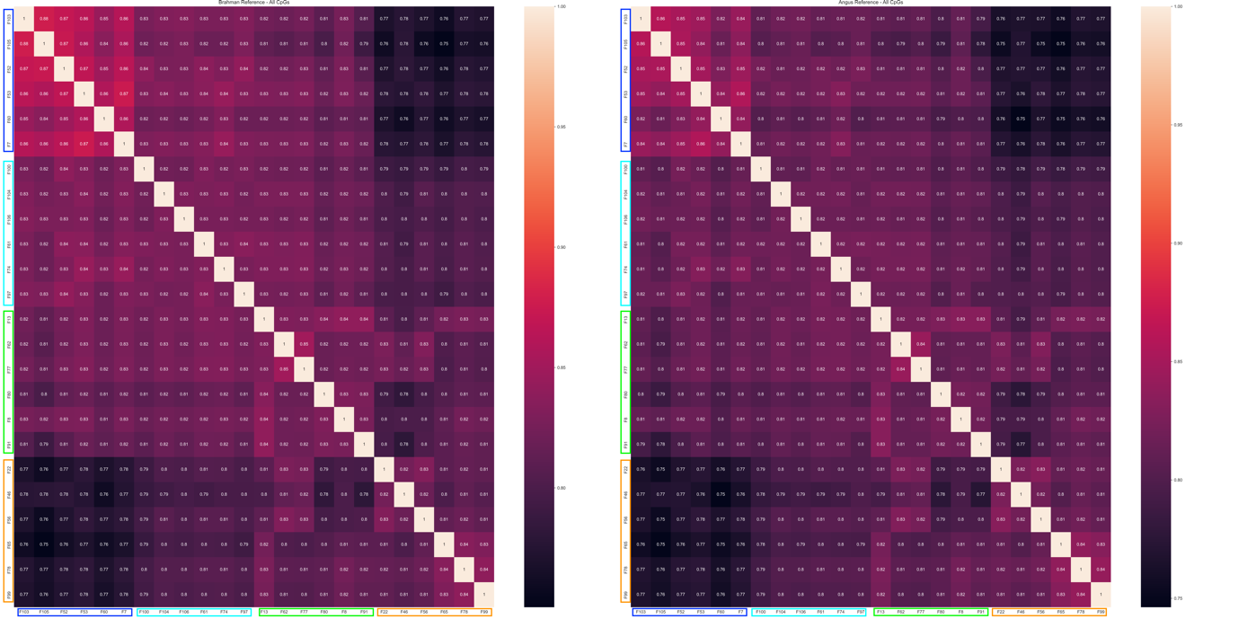

**Supplementary Figure 1. Correlation heat maps of all 24 samples mapped to Brahman and Angus reference genomes. Left)** Correlation heat map for all 24 samples when mapped to the Brahman reference and using all CpGs with ≥ 10X coverage in all samples. Darker colours denote lower correlation. **Right)** Correlation heat map for all 24 samples when mapped to the Angus reference using all CpGs with ≥ 10X coverage in all samples. Darker colours denote lower correlation. Dark blue denotes BTBT samples, cyan denotes BTBI samples, green denotes BIBT samples and orange denotes BIBI samples.

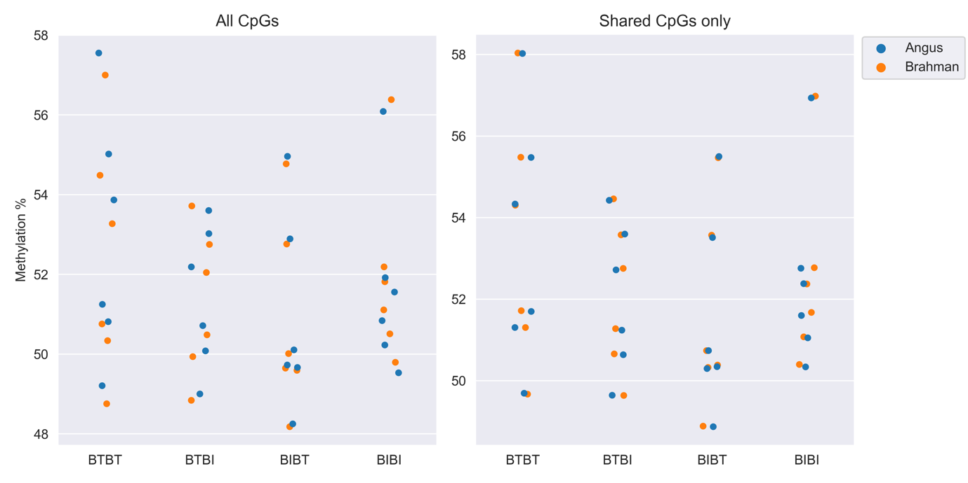

**Supplementary Figure 2.**  Exon methylation across all 24 samples. The x-axis represents the group each sample belongs to. The y-axis represents the mean methylation percentage. The point on the plot represents the mean methylation for each sample at all regions identified as exons. Blue dots represent the mean exon methylation when mapped to Angus. Orange dots represent the mean exon methylation when mapped to Brahman.

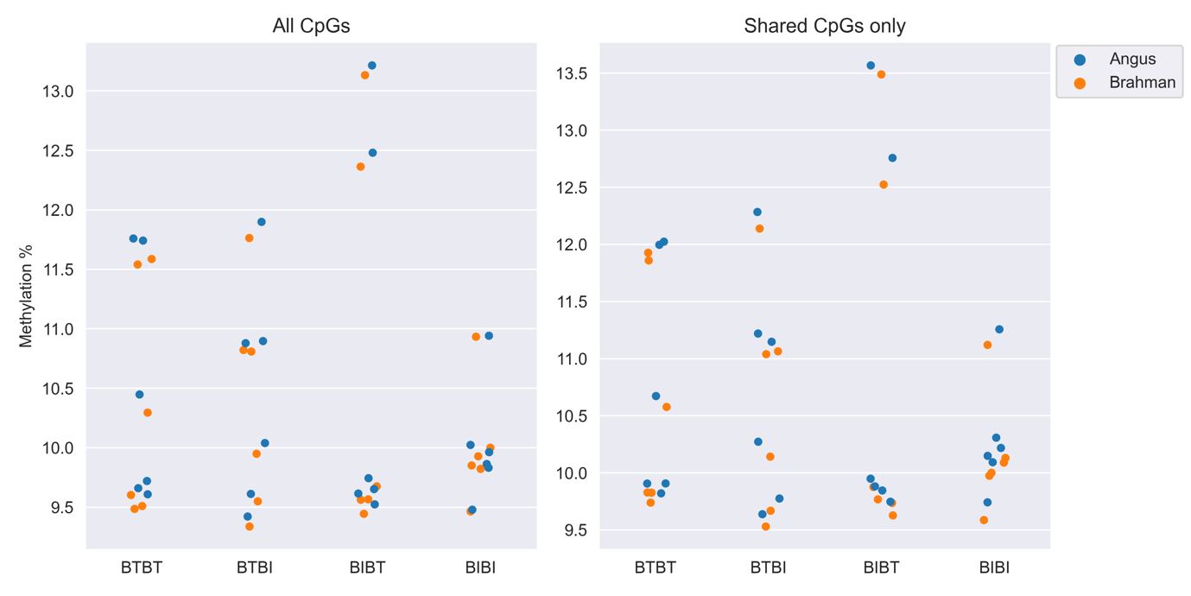

**Supplementary Figure 3.**  5 prime untranslated region (5’UTR) methylation across all 24 samples. The x-axis represents the group each sample belongs to. The y-axis represents the mean methylation percentage. The point on the plot represents the mean methylation for each sample at all regions identified as 5’UTR. Blue dots represent the mean 5’UTR methylation when mapped to Angus. Orange dots represent the mean 5’UTR methylation when mapped to Brahman.

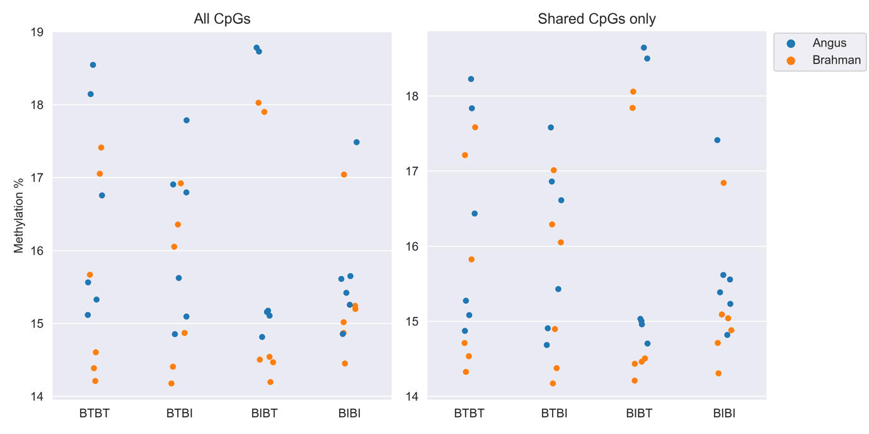

**Supplementary Figure 4.**  Promoter methylation across all 24 samples. The x-axis represents the group each sample belongs to. The y-axis represents the mean methylation percentage. The point on the plot represents the mean methylation for each sample at all regions identified as promoter. Blue dots represent the mean promoter methylation when mapped to Angus. Orange dots represent the mean promoter methylation when mapped to Brahman.

**Supplementary Figure 5.**  Intergenic methylation across all 24 samples. The x-axis represents the group each sample belongs to. The y-axis represents the mean methylation percentage. The point on the plot represents the mean methylation for each sample at all regions identified as an intergenic region. Blue dots represent the mean intergenic methylation when mapped to Angus. Orange dots represent the mean intergenic methylation when mapped to Brahman.

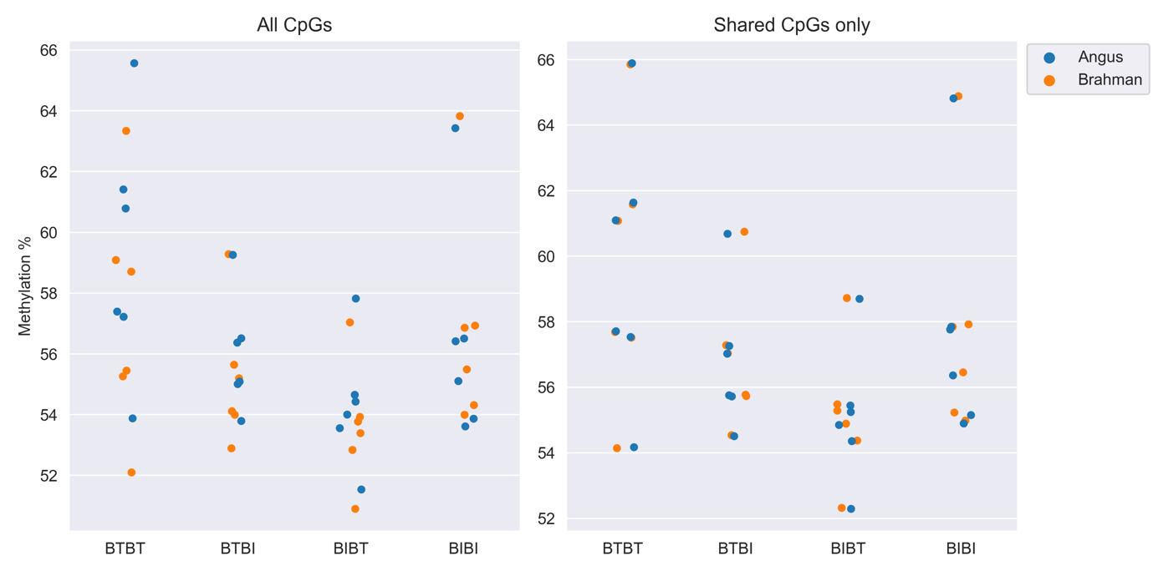

**Supplementary Figure 6.**  Intron methylation across all 24 samples. The x-axis represents the group each sample belongs to. The y-axis represents the mean methylation percentage. The point on the plot represents the mean methylation for each sample at all regions identified as an intron. Blue dots represent the mean intron methylation when mapped to Angus. Orange dots represent the mean intron methylation when mapped to Brahman.

**Supplementary Figure 7.**  3 prime untranslated region (3’UTR) methylation across all 24 samples. The x-axis represents the group each sample belongs to. The y-axis represents the mean methylation percentage. The point on the plot represents the mean methylation for each sample at all regions identified as an 3’UTR. Blue dots represent the mean 3’UTR methylation when mapped to Angus. Orange dots represent the mean 3’UTR methylation when mapped to Brahman.

**Supplementary Figure 8.**  Predicted enhancer methylation across all 24 samples. The x-axis represents the group each sample belongs to. The y-axis represents the mean methylation percentage. The point on the plot represents the mean methylation for each sample at all regions identified as a predicted enhancer. Blue dots represent the mean predicted enhancer methylation when mapped to Angus. Orange dots represent the mean predicted enhancer methylation when mapped to Brahman.

**Supplementary Figure 9.** Comparison of most frequent base substitutions affecting CpG dinucleotides between Brahman and Angus. The top panel shows the most frequent SNPs affecting the first base in the CpG dinucleotide. The colour of the bar represents how often that SNP was observed in Angus (blue) and Brahman (orange). The bottom panel shows the most frequent SNPs affecting the second base in the CpG dinucleotide.

**Supplementary Figure 10.** Boxplot comparing global methylation of Brahman and Angus shared and unique CpGs when mapped to the Angus and Brahman reference genomes. Shared CpGs between the two breeds show identical methylation patterns regardless of the reference genome used. Angus-specific CpGs show relatively high methylation when mapped to the correct genome but show very low methylation when mapped to the Brahman reference genome. The Brahman-specific CpGs show relatively low methylation when mapped to the Angus genome but much higher methylation when mapped to the correct reference genome.

**Supplementary Figure 11. Graphical representation of search region.** For each feature labelled as “gene” in the GTF files for Brahman and Angus, we took 130kb either side of the gene body. The outermost region in green represents the putative enhancer regions; these were 125kb in length, regardless of the size of the gene body. Next were the 5kb regions, which extended 5kb up or downstream of the gene body. Lastly, the gene body was kept as the length that it was in the GTF file.